Student Handbook

For students completing   
courses with the   
Australian Institute of Management

Published by:

Australian Institute of Management

Management House

Cnr Boundary & Rosa Streets

Spring Hill Qld 4000

PO Box 200

Spring Hill Qld 4004

P 07 3227 4888

F 07 3832 2497

W www.aimqld.com.au

Version: 6

Date modified: 20/6/2014

**© 2014 Australian Institute of Management Education and Training All Rights Reserved**

No part of this publication may be reproduced or transmitted in any form or by any means, electronic or mechanical, including photocopying, recording, or by any information or retrieval system, without the prior permission of AIM. Requests for permission to use material contained in this publication should be directed to the General Manager.

This material is issued by AIM on the understanding that:

AIM, its officials, authors, or any other persons or agencies involved in the preparation of this publication expressly disclaim all or any contractual, tortuous, or other form of liability to any person (purchaser of this publication or not) in respect of the publication and any consequences arising from its use, including any omission made, by any person in reliance upon the whole or any part of the contents of this publication.

No person should act on the basis of the material contained in this publication without obtaining advice relevant to his or her own particular situation and without considering and taking specific professional advice as may be necessary.

Unauthorised copy or use of the material may be subject to legal action.

Contents

AIM Courses 4

Course Directory 4

Enrolling in a Course 4

Course Registration and Fees 4

Course Changes 6

Course Materials 6

Statement of Attendance 6

Individual Needs 6

Confidentiality and Privacy 7

Copyright 7

AIM Training Venues 8

Dress 8

Mobile Phones 8

Meals 8

Emergency Procedures and First Aid 8

Nationally Recognised Training 9

Background 9

The AIM Difference 9

Competency Based Assessment 9

Legislation, Policies and Procedures 10

AIM Student Information 11

Statements of Attainment and Qualifications 11

Reissue of Testamur 11

Recognition of Prior Learning 11

Credit Transfer 11

Disciplinary Action 12

AIM Contacts 12

AIM Assessment Guidance 13

Assessment Completion Timeframes – Short Courses 13

Assessment Completion Timeframes – Full Qualification 13

Before Starting the Assessment 13

Confidentiality 13

Suggested Assessment Timeframes 14

Assessment Guide 14

Assessment Types 15

Assessment Layout Requirements 16

Doing the Assessment 16

Key Assessment Requirements 17

Attempt Every Question and Task 17

Before Submitting the Assessment 17

Submitting your Assessment 18

Resubmission 19

AIM Courses

Course Directory

AIMs Course Directory is your connection to a wealth of knowledge and information networks. AIMs courses leverage our experience, resources, learning strategies and delivery methodologies to ensure your individual or organisational success.

To view a copy of our course directory visit our website at [www.aimcourses.com.au](http://www.aimcourses.com.au) or telephone 1300 882 895 and the AIM Client Services team will be more than happy to send you a hard copy.

Enrolling in a Course

Once you have selected your professional development pathway, it’s as easy as calling 1300 882 895 to enrol. The AIM Client Services team can help you with any other queries you may have.

Alternatively, you can register online at [www.aimcourses.com.au](http://www.aimcourses.com.au).

Course Registration and Fees

**Tuition Fees**

* Fees must be paid on enrolment.
* If an approved Purchase Order is provided, an invoice will be issued by AIM for open program enrolments and must be paid no later than 14 days following the date of the invoice. If the fees have not been paid within 14 days an enrolment may be cancelled. An enrolled student will be notified prior to this occurring.
* Enrolments made within 14 days of the first attendance day will only be accepted with payment.
* Payment can be made via electronic funds transfer, credit card or bank draft.
* Where materials (i.e. textbooks and courseware) are issued as part of program preparation this will not occur unless the fees have been paid.

**Cancellations, Refund Policy, Transfers to Alternate Programs**

Notifications of cancellations, refunds and requests for transfers must be made in writing.

More than 10 working days from program commencement

* In the event of a cancellation the Institute will refund the fees paid in full if AIM is advised in writing of a cancellation more than 10 working days prior to the program commencement date.

10 working days or less from program commencement

* In the event of notification of a cancellation 10 working days or less before the program commencement date fees paid will not be refunded or allocated to another program. AIM cannot accept responsibility for changes to work commitments or personal circumstances within this 10 working day period.

**Transfers**

Requests for transfers to alternate programs can be arranged if AIM is advised in writing more than 10 working days prior to the program commencement date and there is availability on the selected program. One transfer will be accepted without charge where AIM has been notified in writing at least 10 working days prior to the scheduled commencement date. All subsequent transfers will attract an administration charge of $55.00 (incl. GST).

**Qualifications - Cancellations**

If a student fails to attend a program that forms part of a qualification or fails to provide AIM with the required 10 days' notice of transfer, a fee will be charged before a transfer to another program will be allowed. This fee will equal 50% of the short course fee for this program.

A partial refund of fees paid may be available in the event of cancellation of a qualification subject to when the written notification of cancellation was received and the number of programs within the qualification already completed.

**Non Attendance (No Show)**

If a student fails to attend a program, program fees will not be refunded or allocated to another program.

**Substitutions**

Requests for substitutions are to be made in writing and can be made at any time up to 2 working days before the program commencement date.

**Goods and Services Tax (GST)**

Advertised prices are GST inclusive. The portion of the program or qualification fee attributable to the education component is GST free, however in accordance with GST legislation AIM is required to charge GST on the portion of the program that relates to catering. Tax invoices that comply with GST legislation will be issued for all enrolments. The amount of GST will be separately identified on all tax invoices.

**General**

* AIM reserves the right to cancel, postpone or re-schedule programs due to low enrolments or unforeseen circumstances. Where a fee refund is due to a student such refund will be processed within thirty days.
* The information provided by AIM was correct at the time of publication but may be subject to change. AIM reserves the right to change programs fees, dates, content, speakers or method of presentation at its discretion.
* AIM reserves the right to video and/or audio record learning sessions for quality assurance purposes and to support students.

**Special Circumstances**

AIM will review its refund policy in cases of special circumstances

Special circumstances include:

* Medical circumstances: where a student’s medical condition has changed to such an extent that he or she is unable attend, or
* Family/Personal circumstances: death or severe medical problems within a family, or unforeseen family financial difficulties, so that it is unreasonable to expect a student to attend, or

Evidence sufficient for a claim of special circumstances shall include (but is not limited to) the following:

* In respect to Medical circumstances, the provision of a medical certificate from a medical practitioner
* In respect to Family/Personal circumstances, a statutory declaration witnessed by a Justice of the Peace, and where family medical problems are cited, a copy of a medical certificate from a medical practitioner

AIM will be satisfied that a student’s circumstances are beyond the student’s control if a situation occurs that a reasonable person would consider is not due to the person’s action or inaction, either direct or indirect, and for which the student is not responsible. The situation must be unusual, uncommon or abnormal.

Each review will be examined and determined on its merits by considering a student’s claim together with independent supporting documentation substantiating the claim.

Course Changes

Course dates, times and course content are occasionally subject to change. Should the need for such changes occur, every effort is made to inform course students prior to the commencement of training.

Where nationally accredited programs are changed in line with changes to competency standards and/or curriculum, a two-year transition phase is provided to allow existing students to complete their qualifications. Qualified staff are available to discuss the impact of changes to competency standards.

Course Materials

Each student in an AIM course will receive a set of comprehensive course materials, including handouts and relevant reference materials.

Statement of Attendance

Each student receives a Statement of Attendance that details the training undertaken and the date the course was attended. The certificate will be presented by the facilitator at the end of the last day of each course.

Individual Needs

AIM is committed to supporting students with individual needs and provides support services ranging from disability access to support in English language, literacy and numeracy. Students with individual needs or requirements for support services are encouraged to contact the AIM Client Services Team on 1300 882 895 at least three working days in advance. This will assist with room allocation and lesson planning.

If you require support with English language, literacy and numeracy issues, AIM will arrange an interview and assessment of abilities with a numeracy or literacy specialist. Some one-on-one support is provided during training and during the assessment process.

Confidentiality and Privacy

AIM sets the highest standards in relation to confidentiality of training records and achievements. AIM respects your right to privacy. We advise that the information that you may provide to us could be Personal Information as defined in the Privacy Act 1988 (Cth).

The provision of the information is voluntary, but if this information is not provided AIM may not be able to process your enrolment or respond to your enquiry.

We may use your Personal Information to inform you about our products and services and may disclose it to Approved Third Parties. If you would like further information on AIM's privacy practices, or on how to access your Personal Information, view our Privacy Statement at [www.aimqld.com.au](http://www.aimqld.com.au) or contact our Privacy Officer on 1300 882 895 or at privacy@aimqld.com.au.

Copyright

No part of AIM’s publications may be reproduced or transmitted in any form or by any means, electronic or mechanical, including photocopying, recording, or by any information or retrieval system, without the prior permission of AIM Qld & NT. Requests for permission to use material contained in any publications should be directed to AIM. Subject to certain conditions we may be able to provide you with materials through a copyright release fee, royalties or a formal licensing arrangement.

AIM Training Venues

Dress

We encourage students to dress in smart, casual and comfortable attire. AIM training venues are air-conditioned. Many students bring a long sleeved top or jacket to account for personal preferences in room temperature.

Mobile Phones

Students are asked to switch off phones or mobile devices or set them to silent mode during class time. Frequent breaks are provided to enable students to check messages.

Meals

Morning, afternoon tea and lunch are included in training fees. Please ensure you inform AIM of any special dietary requirements. Simply notify AIM at least three days prior to the commencement of the course via email [courses@aimqld.com.au](mailto:courses@aimqld.com.au).

Emergency Procedures and First Aid

Each student will receive emergency evacuation instructions upon arrival at the AIM training venue. The course facilitator will provide more instructions in the event of an emergency. Qualified first aid officers are located at AIM premises.

Nationally Recognised Training

Background

Nationally recognised training is any training that meets the outcomes set down in either Training Packages or Accredited Course and endorsed by Industry and Skills Council Advisory Committee. These outcomes have been determined through an extensive consultation process including State and Federal training authorities, industry representatives, employee representatives and Industry Skills Councils (ISCs).

AIM offers a suite of training programs that form the building blocks to the achievement of nationally recognised qualifications, from Certificate IV to Advanced Diploma. Students can choose from a number of speciality areas including Human Resource Management, Business Management, Business Development, Sales, Marketing, Project Management, Training and Assessment and Frontline Management.

Details on AIM nationally recognised qualifications can be found in our Course Directory at [www.aimcourses.com.au](http://www.aimcourses.com.au) or call AIM Client Services on 1300 882 895 to request a printed version.

The AIM Difference

Each Registered Training Organisation (RTO) has the flexibility to develop its own course material around the requirements of the Training Package. The Statement of Attainment and Qualification received upon successful completion of all assessments is nationally recognised and meets the same competency standards as other RTOs. The way in which content is delivered and the experience of facilitators combine to form AIM’s point of difference.

Competency Based Assessment

Each student enrolled in Nationally Recognised Training may choose to undertake assessment, with the aim of obtaining a Statement of Attainment or Qualification. Assessments have been designed with a focus on workplace outputs. Each nationally recognised training program has its own Assessment Kit which provides an assessment tool designed to help you collect evidence of your competency.

To assist in the evidence gathering process a variety of assessment methods are used. These include

1. Assessing required knowledge

2. Assessing the application of skills in the workplace

3. The submission of Third Party Reports

Each assessment method provides a different type of evidence. Taken together, the complete assessment provide well-rounded picture of your ability to perform competently and confidently in the workplace to the level set down in the Competency Standards.

Legislation, Policies and Procedures

AIM has policies and procedures in place that support students and AIM’s accreditation as a Recognised Training Organisation and a Quality Assured organisation under AS/NZS ISO 31000:2009.

Commonwealth legislation (available at [www.comlaw.gov.au](http://www.comlaw.gov.au)):

* Age Discrimination Act 2004 Cwth
* Disability Discrimination Act 1992 Cwth
* Equal Opportunity for Women in the Workplace Act 1999 Cwth
* Fair Work Act 2009 Cwth
* Workplace Gender Equality Act 2012 Cwth
* Independent Contractors Act 2006 Cwth
* Paid Parental Leave Act 2010 Cwth
* Racial Discrimination Act 1975 Cwth
* Sex Discrimination Act 1984 Cwth
* Copyright Act 1968 Cwth
* Copyright Amendment (Digital Agenda) Act 2000 Cwth
* National Vocational Education and Training Regulator Act 2011

As a student, the policies that may have an impact on you include:

* Grievance Resolution
* Workplace Health and Safety
* VET Fairness, equal benefits and opportunities
* Language, Literacy and Numeracy
* Tuition Fee, Refunds, Re-credit and Review

These policies are available on our website at www.aimqld.com.au/training/terms.htm. If you would like a copy of these documents and do not have access to the Internet, please contact AIM Client Services on 1300 882 895.

AIM Student Information

AIM’s Student Information page [www.aimqld.com.au/training/studentinfo.htm](http://www.aimqld.com.au/training/studentinfo.htm) can be used to access the following requirements:

* Assessment Extension Request Form
* [Appeal Assessment Decision Form](http://www.aimqld.com.au/training/documents/AIM-LD108%20Assesment%20Appeal%20Outcome.doc)
* [Re-issue of AIM Statements](http://www.aimqld.com.au/training/documents/Re_issueOfAIMStatments.docx)

Statements of Attainment and Qualifications

A student who has been assessed as competent in a unit of competency will be awarded a Statement of Attainment. The relevant type and number of Statements of Attainment build to provide a Qualification. A Statement of Attainment or Qualification issued by AIM is an official document, imprinted with the Nationally Recognised Training logo and will be recognised by other Registered Training Organisations across Australia.

Reissue of Testamur

To replace a Statement of Attainment or Qualification a Reissue Application Form is available on the AIM website [www.aimqld.com.au/training/studentinfo.htm](http://www.aimqld.com.au/training/studentinfo.htm). Prices are as follows:

|  |  |  |
| --- | --- | --- |
| Certificate | **Definition** | **Cost** |
| Statement of Attendance | For attending a training course | $33.00 |
| Statement of Attainment | For submitting an assessment and being deemed competent for the unit(s) of competency | $33.00 |
| Qualification | For submitting assessment(s) and being deemed competent across a number of units of competency | $55.00 |

Recognition of Prior Learning

Recognition of Prior Learning (RPL) is a legitimate assessment pathway that enables candidates to demonstrate competence from prior experience and learning. RPL candidates submit a portfolio of evidence to AIM for assessment and undergo a competency conversation as part of the assessment process. RPL is available for every accredited course that AIM offers. Please refer to our website for further information on the RPL process: [www.aimqld.com.au/training/rpl.htm](http://www.aimqld.com.au/training/rpl.htm).

Credit Transfer

RTOs in Australia operate within the Australian Quality Training Framework (AQTF) or the NVR VET Quality Framework. Statements of Attainment and Qualifications issued by other RTOs will be recognised by AIM and may count as credit towards a qualification with AIM.

For further advice, please contact the AIM Client Services team on 1300 882 895.

Disciplinary Action

All students are entitled to access face to face sessions and workshops free from disruption by others. If a student disrupts a course it will be brought to the attention of the RTO Manager. After this has been noted on three occasions on the day of delivery, the student will be removed. On more serious occasions, the student may be directly removed from the class at the discretion of the facilitator, in consultation with the RTO Manager. The disciplinary action that is taken will be recorded on their student record for future reference.

AIM Contacts

|  |  |  |  |
| --- | --- | --- | --- |
| Area | Contact | Phone | Email Address |
| Enrolments, transfers, cancellations, refunds and general enrolment enquiries | Client Services | 1300 882 895 | [courses@aimqld.com.au](mailto:courses@aimqld.com.au) |
| Assessments and assessment support | Assessment Coordinator | 1300 882 895 | [assessment@aimqld.com.au](mailto:assessments@aimqld.com.au) |

AIM Assessment Guidance

AIM understands the time constraints that students are under to complete assessments and go about their daily lives. AIM strongly supports completing assessments when the information is still fresh and relevant in your mind.

Assessment Completion Timeframes – Short Courses

For short courses where the assessment is based on one unit of competency there is a 6 week time limit from the day the course is run to when the assessment should be submitted.

For short courses where the assessment is based on two or more units of competency there is a 12 week time limit from the day the course is run to when the assessment should be submitted.

If you cannot submit the assessment by the due date you will need to fill out and send to AIM an Application for Extension form located on the AIM website student Information page.

Assessment Completion Timeframes – Full Qualification

You have two years to complete all units of study within a qualification. For example, if you are enrolled in the Diploma of Management and your first workshop is on 1 October 2015 you will need to complete all relevant units of study by 1 October 2017. If an extension of time is required for individual units during this time, you will need to follow the same process as outlined above.

NOTE: When enrolled in a full qualification composed of multiple short courses the 6 week time frame applies for each individual assessment. The two year time frame is to complete ALL units of study towards a qualification.

Before Starting the Assessment

* Carefully read through the Assessment Kit
* Think about what is being asked of you
* Become familiar with the unit of competency that will be assessed
* Plan the time you will need to answer the questions
* If you have any problems understanding or answering a question or task please seek clarity from the Assessment Coordinator on 1300 882 895 or via assessment@aimqld.com.au

Confidentiality

If you have concerns over the confidential nature of the information in your submission please speak to AIM. AIM assessors and other staff are bound by the Privacy Act. When you submit an assessment with AIM you can be assured that we will treat all workplace information with care.

* All assessment documentation is treated as commercial in confidence.
* All materials submitted will only be used for the purpose of assessment and will be stored securely. Only qualified assessors and administration staff involved in the assessment process will have access to student assessments.

Suggested Assessment Timeframes

Set yourself approximately:

* 8-10 hours per competency to complete each Certificate IV level assessment
* 10-15 hours per competency to complete each Diploma or Advanced Diploma level assessment

Assessment Guide

Use the table below as a reference point for your assessment. It is important to note that the volume of words is less important than answering the question fully and accurately.

|  |  |  |
| --- | --- | --- |
|  | Guide to assessment answers | Approximate guide to length of answers |
| Certificate IV (AQF level 4) | * Your answers may include lists using bullet points, however sentences and short paragraphs are preferred. * Examples of how you apply concepts at work are required. The examples you give must be realistic and achievable for your organisation. * If you use material from other sources, the material must be referenced. | * Underpinning knowledge questions – ½ page per question * Work-based projects – 1 to 1½ pages per task |
| Diploma and Advanced Diploma  (AQF level  5-6) | * Reference to training concepts and how you have applied (or may apply) them at work is expected. Answers may include bullet points, however descriptive answers are expected. * Work-based examples are expected. Complete description of attachments is expected. | * Underpinning knowledge questions – ½ to 1 page per question * Work-based projects – 1½ to 2½ pages per task |

Assessment Types

AIM provides a printed copy of your assessment in the courseware. In addition, we also send each student an electronic assessment version within five working days. We have collated some frequently asked questions in relation to the assessment process which may be of assistance.

|  |  |
| --- | --- |
| Q:  A: | **How many chances do I get to submit my assessment?**  The assessment process allows 3 submission (2 re-submits) before being deemed Competent or Not Yet Competent |
| Q:  A: | **What is the expectation when referencing?**  When referencing websites, books and journals from which you have included quotes use the Harvard Referencing Guidelines. A copy can be found on the AIM Student Information page located on the AIM website [www.aimqld.com.au/training/studentinfo.htm](http://www.aimqld.com.au/training/studentinfo.htm) |
| Q:  A: | **How long do I have to submit my assessment?**  This depends on your enrolment; 2 years in total if you enrolled in a full Qualification; 6 weeks for a short course with one unit of competency; 12 weeks for a short course with two or more units of competency |
| Q:  A: | **What if I cannot submit in the time required?**  Please complete the Assessment Extension request form available from Student Information page on our website |
| Q:  A: | **Can I handwrite the assessment answers?**  Only electronic assessments will be accepted |
| Q:  A: | **How do I use the Electronic Assessment Kit?**  You insert your answer in the spaces provided “candidate enter response here” |
| Q:  A: | **How do I submit pictures and other documents?**  These can be inserted into your Electronic Assessment Kit (in the spaces provided). The kits although locked in spaces, have the full functionality of Microsoft Word 2010. |
| Q:  A: | **How do I use the Electronic Assessment Kit if I have a Mac?**  Windows functionalities in the Assessment Kit are limited using a Mac. If this is the case, refer to the Assessment Kit instructions, questions and requirements provided on the day of your program. Ensure that the Assessment Cover Sheet is completed as required and submit electronically with your assessment evidence. Additional information can be found in your AIM Student Handbook |

Assessment Layout Requirements

If you have limited functionality using the AIM Electronic Assessment Kits, please set out your assessment submission in the following manner electronically.

Scan your signed hard copy assessment with your evidence reference as follows:

Knowledge Question



Work Task



Number each piece of evidence in numerical order (use bold font, italicise or underline). Please label attachments clearly with the question or task number and add a heading and brief description (one sentence) to each piece of evidence to explain what the evidence is showing. For example:

|  |  |  |
| --- | --- | --- |
| **(Task)** |  | **Task 1** |
| **(Headings)** |  | Attachment 1 Minutes of Monthly Team Meeting |
| **(Sentence)** |  | “Attachment 1 is a copy of the minutes of our monthly team meeting. The highlighted actions indicate the action I took as Team Leader in relation to….” |

Doing the Assessment

* Read each question carefully.
* Answer all parts of the question fully. Sometimes a question may have more than one part to it. For example: ‘List the three barriers to communication and discuss one method to overcome each of those barriers’.
* One word answers are not acceptable.
* Use the word “I”. The assessor wants to know what YOU did, how YOU did it, why YOU did it and how well YOU did it.
* Gather and attach relevant evidence of what you have done and achieved. Back up what you say with evidence such as emails, feedback, diary notes, reports and plans.
* Answer each and every question in your own words. Copying directly from the course materials or other sources will result in you having to resubmit the assessment.
* When asked to provide an example from your workplace, be specific. Try to avoid broad, generalised statements about what happens generally in the workplace and discuss actual examples.
* Don't let assessments build up. If you are experiencing difficulties talk to your manager, contact the AIM Assessment unit or complete the AIM Assessment Extension Application on our website www.aimqld.com.au/training/studentinfo.htm.

Key Assessment Requirements

The table below provides a description of key assessment requirements.

|  |  |
| --- | --- |
| Analyse | Break the subject down into its parts and then consider each individually and/or into the inter-relationships between components |
| Choose | Pick one |
| Comment | Make critical observations about the subject |
| Describe | Provide a description of facts, processes and events. Do not attempt to explain, interpret or analyse them. |
| Discuss | Examine both sides of the concept or theory: for and against. Back up with examples of what happens in your workplace. Or use strengths and weaknesses format. |
| Explain | In your own words make the concept clear by using workplace examples |
| List | Make a dot point list of items, one after another (like a shopping list or footy ladder) |
| Outline | Provide an organised description or an ordering of information stating the main point but omitting the details |
| Review | Re-examine, analyse and comment briefly, in an organised sequence, on the major points of an issue |
| State | In your own words |

Attempt Every Question and Task

If you are unable to answer based on your current role please think into the future or use past roles. You may consult and work collaboratively in the planning phases on work based projects, however the completion of the assessment tasks must be entirely your own work.

Before Submitting the Assessment

* Fill out and use as your cover page the Candidate Declaration form. This form MUST be submitted with your assessment. Refer to the following page.
* Check that all of your evidence is labelled clearly.
* Check that every question is answered fully.
* Check that every answer is preceded with the question it is answering.
* Make sure you have a complete copy of your assessment before sending it in case it goes astray and you have to resubmit. Please note that once your assessment has been marked and the result recorded, your submission will be securely destroyed.

Submitting your Assessment

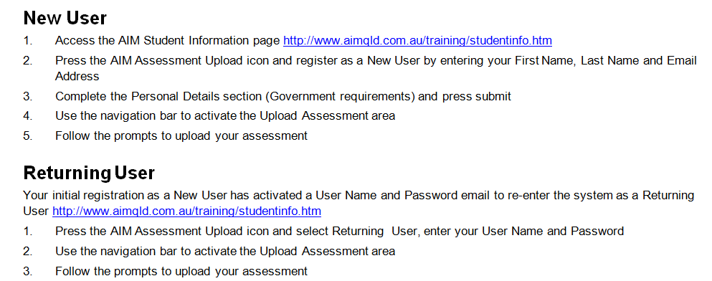Any queries relating to assessment tasks, assessment administration, or your assessment results should be directed to the Assessment Coordinator. Phone 1300 882 895 or email [assessment@aimqld.com.au](mailto:assessment@aimqld.com.au).

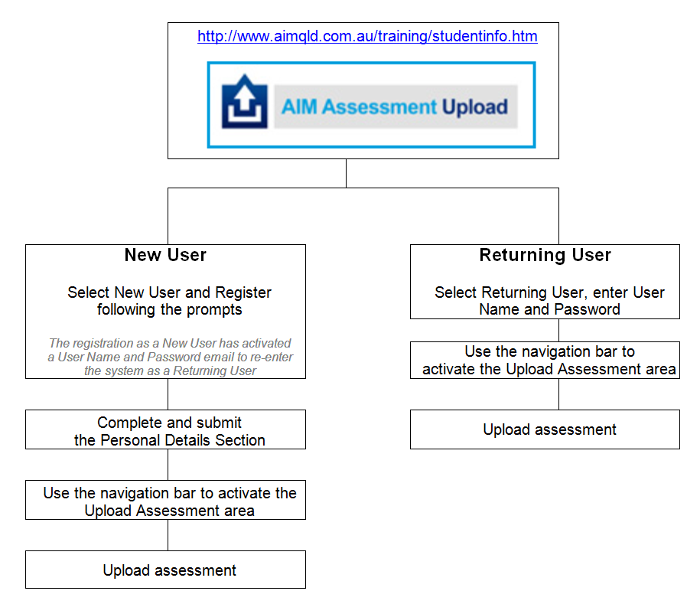

Resubmission

You have two opportunities under AIM’s resubmission process to resubmit your evidence prior to it being deemed Competent or Not Yet Competent.

* You will only be required to resubmit the evidence that is Insufficient
* Some students' work is returned because it is disorganised and difficult for the assessor to read. Please present your work to a standard that would be acceptable in your workplace.
* Make sure you follow the assessor’s resubmission in instructions
* Always ensure that you make a backup copy to avoid issues should your evidence be lost or goes astray (this will mean that you will be able to resubmit without having to redo the whole assessment)
* If you are not clear about what extra evidence you need to provide please contact the **Assessment Coordinator** by:  
  Phone: 1300 882 895  
  Email: [assessment@aimqld.com.au](mailto:assessment@aimqld.com.au)

When resubmitting:

* Read all the comments from your assessor. These comments will identify exactly what you need to resubmit to AIM
* Clearly label each element of the resubmitted work (i.e. Question 1, Task 2, etc)
* If you include additional documents, label each one clearly and identify the Questions or Tasks to which they relate
* Include a brief note to the Assessment Coordinator, advising that you are returning a submission to AIM and date and sign the note

Return to AIM the following:

* A covering letter or note
* The original assessment which will include the Assessor’s Comments Cover Page
* Your resubmission