Application for Recognition of Prior Learning

BSB40212 Certificate IV in Business

|  |  |  |
| --- | --- | --- |
| **Instructions:** | Complete the recognition application and send to AIM. Once the application is received, a student services representative will contact you via the number you have provided in this application. A Recognition of Prior Learning Kit will be forwarded for completion where supplementary evidence of experience will be required. | |
| **Please return to:** | Email: [studentservices@aimqld.com.au](mailto:studentservices@aimqld.com.au) | Phone: 1300 882 895 |

**Personal Details**

|  |  |  |  |  |  |  |
| --- | --- | --- | --- | --- | --- | --- |
| Title: | First Name: | | | Surname: | | |
| Organisation : | | | | Gender: F  M | | Date of Birth: |
| Department: | | | | Email: | | |
| Position: | | | | Mobile: | | |
| Postal Address: | | | | Phone: | | |
| Suburb: | | | State: | Post Code: | | |
| AIM Membership: | | Non member | Personal Member # | | Corporate Member # | |

**Authorising Officer**

|  |  |  |  |
| --- | --- | --- | --- |
| Title: | First Name: | | Surname: |
| Position: | | | Email: |
| Department: | | | Mobile: |
| Postal Address: | | | Phone: |
| Suburb: | | State: | Post Code: |

**Select Units of Competency and Self-Assessment Instruction**

**A person recognised in this qualification,** has well-developed skills and a broad knowledge base in a wide variety of contexts. They apply solutions to a defined range of unpredictable problems, and analyse and evaluate information from a variety of sources. They may provide leadership and guidance to others with some limited responsibility for the output of others.

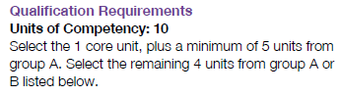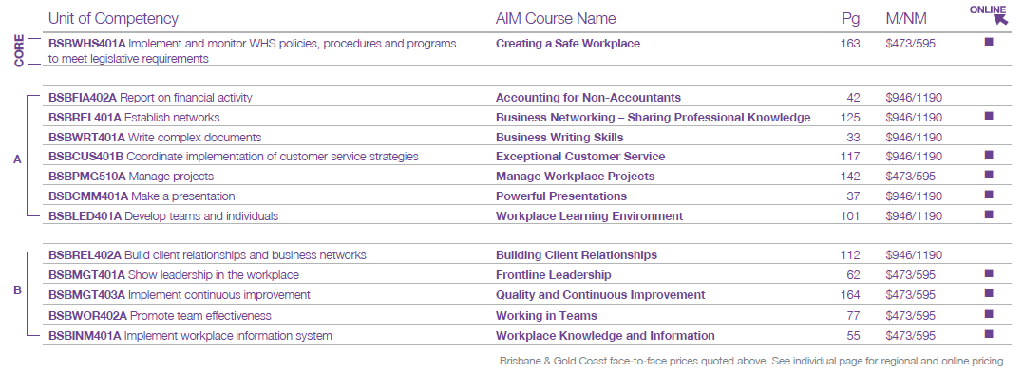

**Unit of competency selection**

| Select unit/s | Unit Code | Unit Title | I have performed these tasks | | |
| --- | --- | --- | --- | --- | --- |
|  |  |  | Frequently | Sometimes | Never |
|  | BSBWHS401A | Implement and monitor WHS policies, procedures and programs  to meet legislative requirements |  |  |  |
|  |  |  |  |  |  |
|  |  |  |  |  |  |
|  |  |  |  |  |  |
|  |  |  |  |  |  |
|  |  |  |  |  |  |
|  |  |  |  |  |  |
|  |  |  |  |  |  |
|  |  |  |  |  |  |
|  |  |  |  |  |  |
| *NOTE: Tasks that you perform either ‘frequently’ or ‘sometimes’ may be considered for RPL. Those you have indicated as ‘never’ will require further training and/or assessment.* | | | | | |

**Pricing**

|  |  |  |  |  |
| --- | --- | --- | --- | --- |
| The RPL assessment fee structure (maximum of 5 units) is as follows; | | | | **AIM Membership**  [www.joinaim.com.au](http://www.joinaim.com.au) |
|  | **One unit** | $ 236.50 for AIM Members | or $ 276.50 for non-members |
|  | **Two units** | $ 473.00 for AIM Members | or $ 553.00 for non-members |
|  | **Three units** | $ 709.50 for AIM Members | or $ 829.50 for non-members |
|  | **Four units** | $ 809.50 for AIM Members | or $ 929.50 for non-members |
|  | **Five units** | $ 909.50 for AIM Members | or $1,029.50 for non-members |
|  | | | |
|  | **Full Qualification** | $1,159.50 for AIM Members | or $1,279.50 for non-members |

|  |
| --- |
| **Payment**  For your privacy and security, AIM will call you to process credit card or direct debit payments via telephone after receiving this application.  **Terms & Conditions**  In providing your email address, AIM has assumed inferred consent to contact you about its products and services via commercial electronic messaging. **Privacy:** We may use your Personal Information to tell you about our products and services and may disclose it to Approved Third Parties (see our Privacy Statement). If you would like further information on AIM's Privacy practices, or on how to access your Personal Information, view our Privacy Statement at **www.aimqld.com.au** or contact our Privacy Officer on 1300 882 895 or at [**privacy@aimqld.com.au**](mailto:privacy@aimqld.com.au). |