Application for Recognition of Prior Learning

BSB60907 Advanced Diploma of Management (Human Resources)

|  |  |  |
| --- | --- | --- |
| **Instructions:** | Complete the recognition application and send to AIM. Once the application is received, a student services representative will contact you via the number you have provided in this application. A Recognition of Prior Learning Kit will be forwarded for completion where supplementary evidence of experience will be required. | |
| **Please return to:** | Email: [studentservices@aimqld.com.au](mailto:studentservices@aimqld.com.au) | Phone: 1300 882 895 |

**Personal Details**

|  |  |  |  |  |  |  |
| --- | --- | --- | --- | --- | --- | --- |
| Title: | First Name: | | | Surname: | | |
| Organisation : | | | | Gender: F  M | | Date of Birth: |
| Department: | | | | Email: | | |
| Position: | | | | Mobile: | | |
| Postal Address: | | | | Phone: | | |
| Suburb: | | | State: | Post Code: | | |
| AIM Membership: | | Non member | Personal Member # | | Corporate Member # | |

**Authorising Officer**

|  |  |  |  |
| --- | --- | --- | --- |
| Title: | First Name: | | Surname: |
| Position: | | | Email: |
| Department: | | | Mobile: |
| Postal Address: | | | Phone: |
| Suburb: | | State: | Post Code: |

**Select Units of Competency and Self-Assessment Instruction**

**A person recognised in this Advanced Diploma qualification,** provides leadership and strategic direction in the human resources activities of an organisation. They analyse, design and execute judgement using wide ranging technical, creative, conceptual or managerial competencies. Their knowledge base may be highly specialised or broad within the human resources field. These individuals are often accountable for group outcomes and for the overall performance of the human resources function of any organisation.

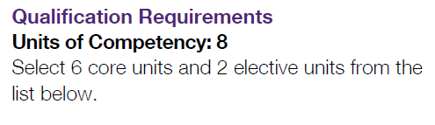

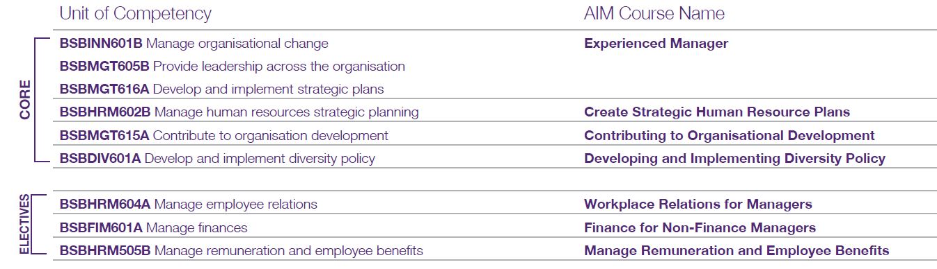

**Unit of competency selection**

| Select unit/s | Unit Code | Unit Title | I have performed these tasks | | |
| --- | --- | --- | --- | --- | --- |
| Frequently | Sometimes | Never |
|  | BSBINN601B | Manage organisational change |  |  |  |
|  | BSBMGT605B | Provide leadership across the organisation |  |  |  |
|  | BSBMGT616A | Develop and implement strategic plans |  |  |  |
|  | BSBHRM602B | Manage human resources strategic planning |  |  |  |
|  | BSBMGT615A | Contribute to organisation development |  |  |  |
|  | BSBDIV601A | Develop and implement diversity policy |  |  |  |
|  |  |  |  |  |  |
|  |  |  |  |  |  |
| *NOTE: Tasks that you perform either ‘frequently’ or ‘sometimes’ may be considered for RPL. Those you have indicated as ‘never’ will require further training and/or assessment.* | | | | | |

**Pricing**

|  |  |  |  |  |
| --- | --- | --- | --- | --- |
| The RPL assessment fee structure (maximum of 5 units) is as follows; | | | | **AIM Membership**  [www.joinaim.com.au](http://www.joinaim.com.au) |
|  | **One unit** | $ 236.50 for AIM Members | or $ 276.50 for non-members |
|  | **Two units** | $ 473.00 for AIM Members | or $ 553.00 for non-members |
|  | **Three units** | $ 709.50 for AIM Members | or $ 829.50 for non-members |
|  | **Four units** | $ 809.50 for AIM Members | or $ 929.50 for non-members |
|  | **Five units** | $ 909.50 for AIM Members | or $1,029.50 for non-members |
|  | | | |
|  | **Full Qualification** | $1,159.50 for AIM Members | or $1,279.50 for non-members |

|  |
| --- |
| **Payment**  For your privacy and security, AIM will call you to process credit card or direct debit payments via telephone after receiving this application.  **Terms & Conditions**  In providing your email address, AIM has assumed inferred consent to contact you about its products and services via commercial electronic messaging. **Privacy:** We may use your Personal Information to tell you about our products and services and may disclose it to Approved Third Parties (see our Privacy Statement). If you would like further information on AIM's Privacy practices, or on how to access your Personal Information, view our Privacy Statement at **www.aimqld.com.au** or contact our Privacy Officer on 1300 882 895 or at [**privacy@aimqld.com.au**](mailto:privacy@aimqld.com.au). |